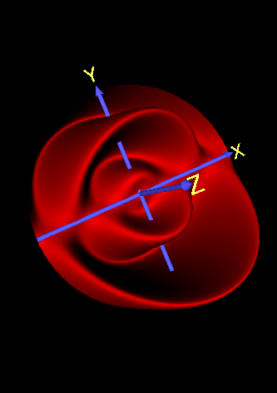

Lab 5 Report

Morphing

SSR3

Yuhan Zhang | CZ2003 Computer Graphics and Visualization | 10 November 2019

Seat number = 85;

Shape number 1 = 7;

Shape number 2 = 10;

Morphing: Number 7 to Number 10

|  |  |  |
| --- | --- | --- |
| **Shape 1** | **Shape 2** | |
| Above shows the first shape (shape before morphing), which is number 7 in the lab manual. The equation that defines this shape is:  x=cos(0.5*a)*(sin(b))^3;  y=sin(0.5*a)*(sin(b))^3;  z=cos(b);  Parameters of a and b are [0 4*pi 0 pi].  The sampling resolution is [75 75].  The file that corresponds to this shape is named ‘Shape_1.wrl’. | Above shows the second shape (shape after morphing), which is number 10 in the lab manual. The equation that defines this shape is:  x=0.5*((d-0.5*sin(d))-3);  y=0.5*cos(4*c*pi)*(1-0.5*cos(d));  z=0.5*sin(4*c*pi)*(1-0.5*cos(d));  Parameters of c and d are [0 0.5 0 2*pi].  The sampling resolution is [75 75].  The file that corresponds to this shape is named ‘Shape_2.wrl’. | |
| **Modified Formula Shape 1** | **Modified Formula Shape 2** | |
| x=cos(2*pi*u)*(sin(pi*v))^3;  y=sin(2*pi*u)*(sin(pi*v))^3;  z=cos(pi*v);  Parameters of u and v are [0 1 0 1]. | x=0.5*(((2*pi*v)-0.5*sin(2*pi*v))-3);  y=0.5*cos(2*u*pi)*(1-0.5*cos(2*pi*v));  z=0.5*sin(2*u*pi)*(1-0.5*cos(2*pi*v));  Parameters of u and v are [0 1 0 1]. | |
| **Notes** | | |
| For morphing to be possible between the two shapes, their u and v parameters must be the same, thus the parameters for both shapes were standardized to be [0 1 0 1]. Their equations were changed accordingly, as shown above. | | |
| **Animation of Morphing** | | |
| Step 1 | | Step 2 |
|  | |  |
| Step 3 | | Step 4 |
|  | |  |
| **Notes** | | |
| The resolution for morphing is set at [30 30].  The file that corresponds to this morphing sequence is name ‘morphing_animation.wrl’. | | |
| **Changing Resolution** | | |
| By changing the resolution from [10 10] to [100 100], it is evident that the best resolution occurs at around [30 30]. If the resolution is set to be lower, the animation appears to have more jitters. On the other hand, if the resolution is set to be higher, the animation also appears to have more jitters due to the limited capabilities of the system the animation is ran on. | | |

Morphing

|  |
| --- |
| **Morphing Compared** |
| Resolution set at [30 30]. File named ‘morphing_compared.wrl’ |
|  |